Aardman Animations HQ / Bristol

Schöck Isokorb installed at Wallace and Gromit’s new home

Oscar-winning Aardman Animations is known throughout the world for its film animation work, and in particular the endearing and carefully developed characters Wallace and Gromit. Recently the Bristol based studio has been involved in another careful development, the construction of a brand new three-storey £10m headquarters which includes a mini cinema presentation suite, office space and new catering facilities.

The new HQ provides office and studio space, arranged around a tapered atrium providing break out spaces, daylight and air movement for the natural ventilation. The building is designed to be highly sustainable in both its materials and use of energy and externally features a brise soleil to prevent solar gain inside the building.

Unlike a series of blinds or awnings, which can be extended or retracted, the brise soleil is a permanent structure – and heavy. Because of its weight the brise soleil is structurally connected to the floor slab by steel beams, and as a result has to meet the requirements of Part L of the Building Regulations 2006, which demand a thermal break solution to prevent cold bridging.

The solution here is the type KS14 Isokorb® from market leaders Schöck – a module positioned between the outer and inner structural connection points that blocks the outflow of heat through the use of high quality polystyrene insulation foam. This polystyrene core sits inside a compression module that has stainless steel bars passing through it, which in turn take the tension and shear forces between the building frame – and on this occasion the brise soleil – which runs along the whole of one side of the new building.
The Isokorb® thereby enables a thermally insulated, load bearing connection to be made between reinforced concrete and steel construction components, and at the same time provides a clean and unobtrusive connection detail.

Leadbitter’s, who are fast establishing themselves as one of the leading contractors in the UK, were the main contractors and their Project Manager, Paul Nash, comments: “It was absolutely critical with this particular application that each Isokorb® was installed in precisely the right position. We had to work to tolerances of only one or two millimetres when installing the modules, and their ease of installation really helped. They are relatively light and can be fitted easily by one man in a matter of minutes and it is also possible to adjust and fine-tune on site to optimise the fitting tolerance”.

The Isokorb® dramatically reduces thermal energy loss in connective areas by guaranteeing the homogeneity of the thermal envelope between cantilever structures and the internal floor. In addition, it also transfers load and maintains full structural integrity, while at the same time enabling inner surface area temperatures to remain well in excess of those likely to cause mould formation and condensation.

The units are also designed to help meet compliance with the UK building regulations. These state that the temperature factor used to indicate condensation risk (fRSI), as described in BRE IP1/06 – a document cited in Building Regulations Approved Documents Part L1 and L2 and Section 6 in Scotland – must be greater than, or equal, to 0.75 for dwellings. For commercial buildings it must be greater than, or equal to 0.50. Furthermore, it enables optimum compliance with the Building Regulations Approved Documents by using numerical modelling to calculate the building’s energy performance.

Then there is compliance with the Government Standard Assessment Procedure SAP 2005, concerning CO2 emissions from buildings and respectively heat losses through non-repeating thermal bridges – such as balconies. Here the given thermal values of the Schöck Isokorb® will enable the energy losses through balconies, canopies and other cantilever parts of the building to be reduced considerably, potentially by as much as 84% to 91%.

In addition to its exceptional thermal performance ratings, the Schöck Isokorb® range is also unique on two counts. It is the only range to offer thermal break solutions for connections between concrete-to-concrete, concrete-to-steel and steel-to-steel – and it is also the only product of its type able to provide BBA Certification for the concrete-to-concrete and concrete-to-steel ranges.

There are more than two hundred and fifty standard solutions available in the Schöck range and modules can be tailored to suit practically any application, with different types enabling the transmission of shear, bending moment and tension, as well as compression.

Wallace himself would no doubt have been delighted to have invented the Isokorb®, with Gromit’s help of course.

- Ends –
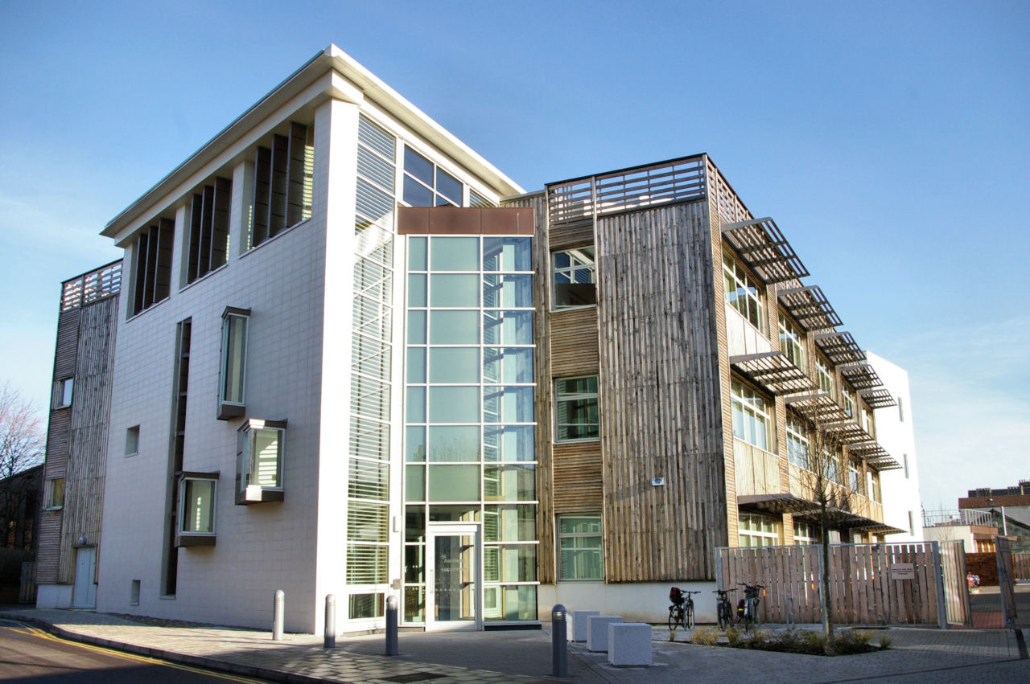

Caption: Aardman Animations, Bristol

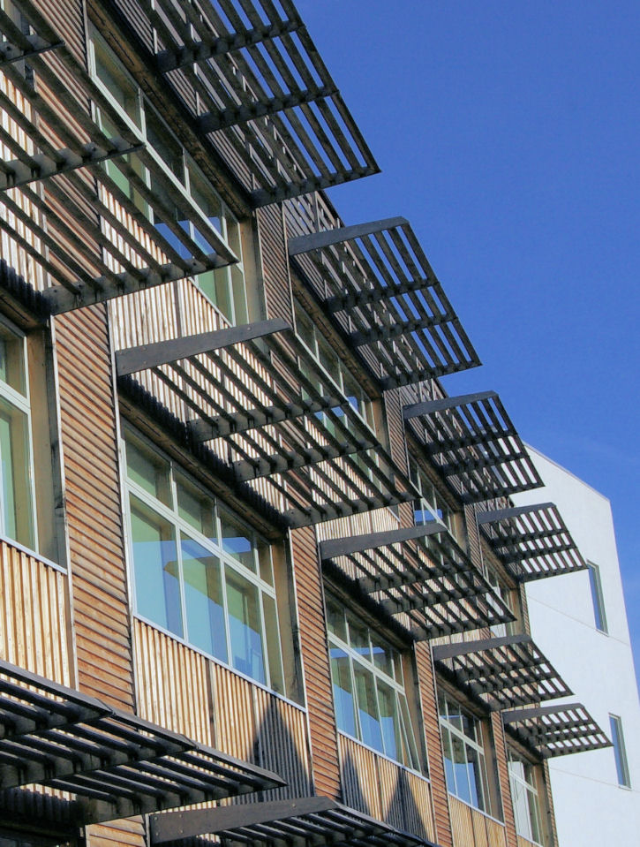
Caption:
Aardman Animations, Bristol

Notes to the editor

A leading European supplier
Schöck has grown to become Europe’s leading supplier of innovative structural load bearing insulation products. Its headquarters are at Baden-Baden in southern Germany and there are subsidiary companies in Great Britain, France, Austria, Switzerland, the Netherlands, Poland and Hungary. Sales teams and partners operate in many other European countries and also Canada and the Middle East. Schöck is committed to providing the highest level of technical back up and comprehensive customer service to the construction industry.

