The Athena Building – 160 -170 Stratford High Street
July 2010

Schöck thermal break modules for Stratford tower

Construction is nearing completion on The Athena Building, a major residential development in Stratford, East London. The imposing 28 storey tower, which stands at the junction of 160 Stratford High Street and Warton Road, takes full advantage of its corner position with an expansive curving front. The higher level apartments offering panoramic views across London and perhaps more importantly in the short term, the Olympic Park.

Designed by Stock Woolstencroft Architects, the prestigious 80 metre high building has low-rise wings set perpendicular to each other along the L shaped site. The development providing 298 one, two and three bedroom flats; plus 1,115 square metres of ground floor mixed commercial space suitable for retail or office use.

Built with modern living in mind, Athena incorporates Italian designer kitchens, luxurious fully tiled bathrooms – and balconies which are very much a feature. These are designed as a combination of curved and straight units, some cantilevered and others inset. Attractive and functional as they are, balconies and other cantilever construction elements projecting through the building envelope and breaking the insulation layer in the process, are notorious for creating thermal bridges. This is where materials that are poor insulators allow substantial heat and energy loss to flow out of the building.

Legislation, along with the need for energy conservation and a reduction in CO₂ emissions, demand that preventing thermal bridging is now a critical consideration in the construction process. One of the most effective solutions is the Isokorb® range of thermal break modules from Schöck. The products in the Schöck range are unique in being the only thermal break solutions to allow connections to be made between concrete-to-concrete, concrete-to-steel and steel-to-steel. Additionally, the concrete-to-concrete and concrete-to-steel ranges are the only BBA certificated thermal break modules available on the market, with steel-to-steel pending.

The Athena Building has a reinforced concrete frame and as a result, the module known as the type K, specifically for concrete-to–concrete connections, has been incorporated into the development. The type K Isokorb® has outstanding thermal insulation properties and dramatically reduces thermal energy loss in connective areas by guaranteeing the homogeneity of the thermal envelope between cantilever structures and the internal floor. It also transfers load and maintains full structural integrity, while at the same time enabling inner surface area temperatures to remain well in excess of those likely to cause mould formation and condensation – both of which are completely eliminated in room areas adjacent to the balconies.

A 20 page ‘Specifiers Handbook‘ is available which provides an overview and introduction to the Schöck Isokorb®., and there is a comprehensive 236 page ‘Technical Guide’ which displays in detail the complete range of thermal break applications for all construction types – concrete-to-concrete, concrete-to-steel, steel-to-steel and concrete-to-timber.

For further information about services from Schöck, or to request a free copy of the Specifiers Guide and / or Technical Guide; contact Schöck Ltd on: tel: 0845 241 3390; fax: 0845 241 3391 or visit www.schoeck.co.uk

- Ends –

Notes to the editor

A leading European supplier
Schöck has grown to become Europe’s leading supplier of innovative structural load bearing insulation products. Its headquarters are at Baden-Baden in southern Germany and there are subsidiary companies in Great Britain, France, Austria, Switzerland, the Netherlands, Belgium, Poland, Italy and Hungary. Sales teams and partners operate in many other European countries and also Canada and the Middle East. Schöck is committed to providing the highest level of technical back up and comprehensive customer service to the construction industry.

[Athena Building_1.jpg]
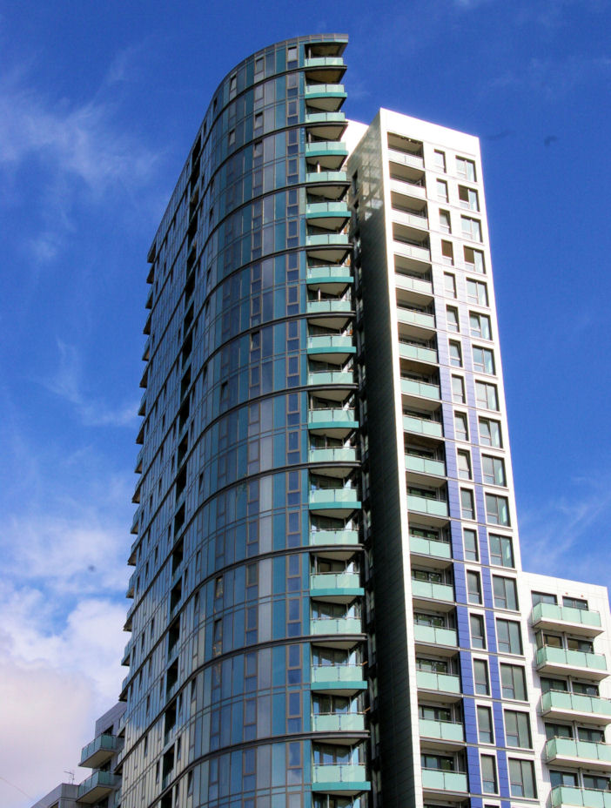

Caption:
The Athena Building, a major residential development in Stratford, East London.

[Athena Building_2.jpg]



Caption:
Balconies - Built with modern living in mind.

