Latest 80mm Schöck Isokorb is more thermally efficient than ever

From Spring 2010, the tried and trusted Schöck Isokorb® thermal break system, designed to prevent thermal bridging at balcony and other critical cantilever connections, is more effective than ever. This is due to a combination of more thermally efficient materials and an increase in thickness to 80mm.

There is a high thermal efficiency (HTE) compression module at the heart of the Isokorb®. This now incorporates a new material made of a steel fibre reinforced ultra high-performance concrete (UHPC), plus the additive Kronolith®, a titanium iron ore with a nominal thermal conductivity. The combination results in thermal conductivity being reduced by a good 40 percent compared to the existing HTE module. Added to this, there is also a change of (EPS) polystyrene to the highly efficient Neopor® from BASF, which has the effect of improving the overall performance of the Isokorb® by 20 percent.

Stainless steel bars pass through the compression module, which in turn take the tension and shear forces between the building frame and the balcony. These transfer load and maintain full structural integrity, while at the same time keep inner surface area temperatures well above those likely to cause mould formation and condensation. The new developments result in an excellent combination of reliability, strength and optimised thermal insulation.
This latest upgrade is a response from Schöck to recent European trends towards much higher insulation standards. In the UK, steps to achieving this target require that energy efficiency standards for new homes are to be improved by 25 per cent in 2010; and 44 per cent in 2013 relative to current 2006 standards. The Government also wants to introduce improved energy efficiency standards for new non-domestic buildings and its ambition for all new non-domestic development is net zero carbon from 2019.

Many EU countries already demand minimum energy standards for new build and restoration projects and some of the key contributing factors are better exterior insulation, highly efficient heating systems, the application of renewable energies – and the minimisation of thermal bridges.

It is a concept strengthened by various certification systems and energy labels such as the "Energy Efficiency House" in Germany; the Swiss "Minergie" standard for buildings; the Italian "Climate House" standard adopted in March 2010 and BREEAM, perhaps the leading and most widely used environmental assessment method for buildings.

- Ends -

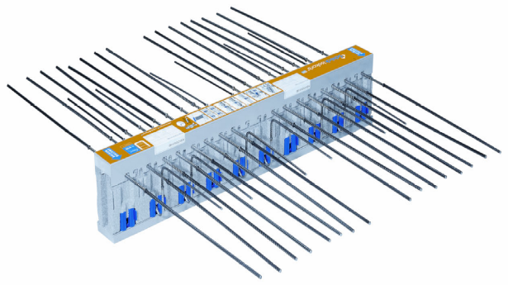

Caption:
The Isokorb HTE-module with 80mm insulation

The new Isokorb HTE-module with 80mm insulation thickness

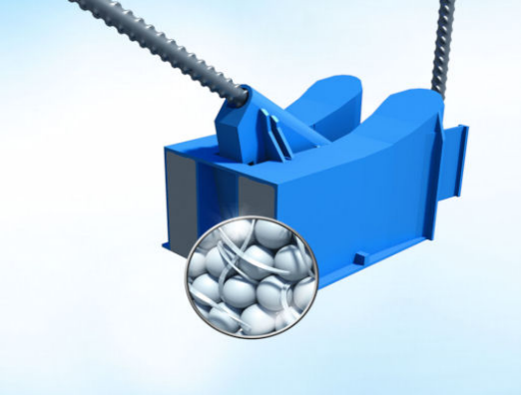
Caption:
The optimised compression module

Notes to the editor

A leading European supplier
Schöck has grown to become Europe’s leading supplier of innovative structural load bearing insulation products. Its headquarters are at Baden-Baden in southern Germany and there are subsidiary companies in Great Britain, Canada, France, Austria, Switzerland, the Netherlands, Poland and Hungary. Sales teams and partners operate in many other European countries and also the Middle East. Schöck is committed to providing the highest level of technical back up and comprehensive customer service to the construction industry.

